PROJECT REPORT & SYNOPSIS

SHOOTER GAME

“ 2D SHOOTER GAME WITH AI AND
DIFFICULTY LEVELS”

SYNOPSIS & PROJECT REPORT SUBMITTED FOR THE PARTIAL
FULFILMENT OF THE REQUIREMENT FOR THE THREE YEARS
DIPLOMA IN

“INFORMATION TECHNOLOGY”
SESSION: 2023–2025

SUBMITTED TO:
FEROZE GANDHI POLYTECHNIC RATAPUR, RAEBARELI

SUBMITTED BY: SHRESTH DIXIT
Enrollment: E23222439000005

Under the Guidance of:
MRS. APOORVA SINGH
CERTIFICATE

This is to certify that the project entitled “Shooter Game – A 2D Game Using Python & Pygame” has been successfully completed by:
- SHRESTH DIXIT

Under the guidance of :
MRS. APOORVA SINGH
(Lecturer, Department of Information Technology)

This project has been submitted in partial fulfillment of the requirements for the three-year Diploma in “Information Technology” during the academic session 2023 – 2025 at
FEROZE GANDHI POLYTECHNIC, RATAPUR, RAEBARELI.

Guide’s Signature: _______________________

HOD’s Signature: _________________________

Date: _______________

ACKNOWLEDGEMENT

We would like to express my sincere gratitude to my project guide, Mrs. Apoorva Singh, for their constant support, guidance, and encouragement throughout the development of my project titled
“Shooter Game – A 2D Game Using Python and Pygame.”

We are also thankful to the faculty and staff of the Information Technology Department, Feroze Gandhi Polytechnic, Raebareli, for providing infrastructure and technical support.

Special thanks to my family and friends for their motivation and support during the entire journey.

This project has been a great learning experience, and we are truly grateful to everyone who helped me complete it successfully.

INDEX TABLE OF CONTENTS
S. No. | Title of Section | Page No.
1. | Title Page | i
2. | Certificate | ii
3. | Acknowledgement | iii
4. | Abstract / About the Project | 1
5. | Objective of the Project | 2
6. | Feasibility Study | 3
7. | SDLC & Project Planning | 4
8. | Software Requirements | 5
9. | Project File Structure | 6
10. | Modules in Project | 7
11. | Module Descriptions | 8
12. | Game Flow Explanation | 9
13. | Snapshots with Explanations | 10
14. | Future Scope | 11
15. | Conclusion | 12

ABSTRACT

The Shooter Game Project is a 2D two-player shooting game developed using Python and the Pygame library. The game allows two modes: Player vs Player and Player vs AI. It features dynamic difficulty that increases with time, basic AI behavior, power-ups (future enhancement), and a graphical game-over menu.
The project aims to provide real-time interaction with keyboard controls, bullet mechanics, and health tracking, giving a solid introduction to game logic, user interface design, collision detection, and basic artificial intelligence concepts in games.

ABOUT THE PROJECT

The “2D Shooter Game in Pygame” is a multiplayer action game developed using the Python programming language and the Pygame library. The objective of the game is to create an engaging shooting battle between two players — either two human players (2P Mode) or one human player against a computer-controlled AI player (AI Mode).
This project demonstrates the core principles of game development such as:
- Player movement
- Bullet firing mechanism
- Collision detection
- Health management
- Dynamic difficulty adjustment
- AI-based enemy logic
- Game Over screen with interactive options
The game features a split-screen layout, simple and clean graphics, background music, and sound effects to enhance the gaming experience. The gameplay becomes more challenging over time due to an automatic level-up system that increases bullet speed.
The code structure of the game is modular — each feature (like AI control, difficulty settings, power-ups, and game-over screen) is handled in separate Python files. This makes the code easier to read, understand, and update in the future.
This project is ideal for beginners who are learning Python and want to build a complete working game. It provides a strong foundation in event handling, real-time updates, and object-oriented programming, and serves as a stepping stone to more complex game development projects.

OBJECTIVE OF THE PROJECT

- To design and develop a 2D shooter game using Python and Pygame.

- To demonstrate two game modes: Player vs Player and Player vs AI.

- To implement AI logic to simulate a computer-controlled enemy.

- To introduce increasing difficulty through bullet speed changes.

- To create a clean user interface and interactive game menu.

- To use modular file structures for scalable game logic.

- To practice concepts of loops, collision, sprite handling, and UI in Pygame.

FEASIBILITY STUDY
A feasibility study evaluates whether a project is practical and achievable within given constraints. It examines four key aspects: operational, technical, schedule, and economic feasibility. Below is the detailed feasibility analysis of the 2D Shooter Game using Pygame:

1. Operational Feasibility
- Game works offline without internet.
- Easy to play with simple keyboard controls.
- Clear menus and smooth gameplay for all users.

2. Technical Feasibility
- Made using Python and Pygame (both are free).
- Runs on normal computers, no high-end PC needed.
- Code is modular and easy to update.

3. Schedule Feasibility
- Project completed within summer training period.
- All modules were developed and tested on time.

4. Economic Feasibility
- No money spent on tools or software.
- All libraries and assets used are free.

PROJECT PLANNING & SOFTWARE DEVELOPMENT LIFE CYCLE (SDLC)

1. Requirement Analysis
Defined all the features to be included, such as game modes, AI behavior, and difficulty levels.

2. System Design
Created flowcharts and wireframes for layout, player zones, and movement logic.

3. Coding
Implemented the design using Python and Pygame. Files were modularized into separate components like AI, difficulty, powerups, etc.

4. Testing
The game was tested in both game modes (Player vs Player and Player vs AI). All bugs were resolved.

5. Implementation
The final version was packaged and presented as a working project.

6. Maintenance
Future plans include adding new features like power-ups, sound improvements, and saving scores.
SOFTWARE REQUIREMENTS

- Language: Python 3.x

- Library: Pygame

- IDE: VS Code or PyCharm

- Platform: Windows or Linux

PROJECT FILE STRUCTURE

1. main.py –
Contains the game’s main logic, player controls, UI setup, and main loop.

2. ai_player.py –
Controls the behavior of the computer (AI) player.

3. difficulty.py –
Manages game difficulty, like increasing bullet speed after specific intervals.

4. powerups.py –
[Future Scope] Adds power-ups like health and speed boosters.

5. gameover.py –
Displays the Game Over screen with Restart and Exit options.

6. Assets Folder –
Includes required images (Shooter.png), background (Brown2.jpg), and sound effects (Play.mp3, Sound.mp3).

MODULES IN PROJECT

- Player vs Player Game Mode

- Player vs AI Game Mode

- Health Tracking System

- Difficulty Level Manager

- Game Over Screen

- Power-Ups (Planned)

MODULE DESCRIPTIONS

Player Movement: - WASD for Player 1, Arrow Keys for Player 2

AI Behavior: - Follows Player 1 vertically and fires bullets

Bullet Logic: - Collision reduces health; bullets disappear after hit

Health System: - 10 health points per player; game ends at 0
Difficulty Control: - Bullet speed increases every 30 seconds

Game Menu: - Start with mode select (1 for PvP, 2 for PvAI)

Game Over: - Shows winner, options to Restart or Quit

Power-Ups: - [In progress] – Health and Speed boosts spawning every 20 seconds

GAME FLOW EXPLANATION

- Start Screen appears with options (1 / 2)

- Player(s) selected and control mapping initialized

- Game loop handles movement, fire, collision

- AI (if selected) tracks and fires at opponent

- Every 30 seconds: level increases, bullet speed increases

- When health reaches 0: Game Over screen with Restart/Quit

- (In future) Power-ups will spawn periodically to help players

PROJECT SNAPSHOTS WITH EXPLANATION

Screenshot 1A: Start Menu Code Snippet
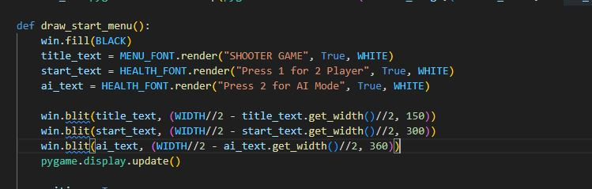

Screenshot 1B: Start Menu Output
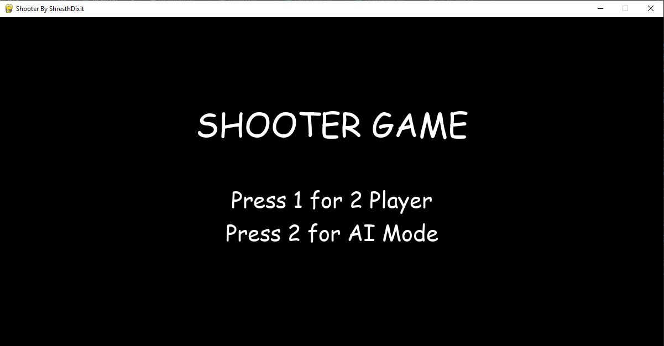
Explanation: This part controls the display of the start menu using Pygame and takes user input through the keyboard. The player can choose between Player vs Player mode or Player vs AI mode by pressing keys ‘1’ or ‘2’.

Screenshot 2A: AI Player Code Snippet
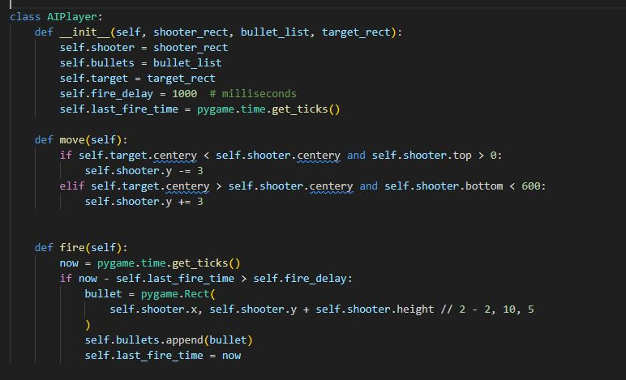

Screenshot 2B: AI Logic Output
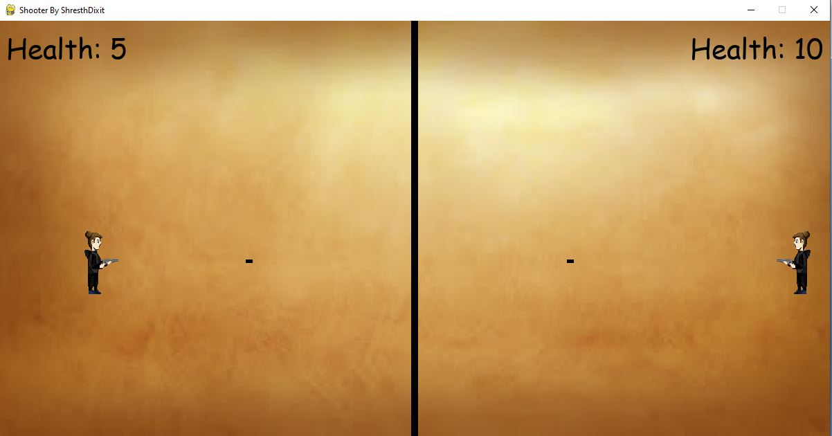
Explanation: This module defines AI behavior. The AI player automatically tracks the vertical position of the human player and shoots bullets at a fixed time interval (every 1 second).

Screenshot 3A: Difficulty Manager Code Snippet
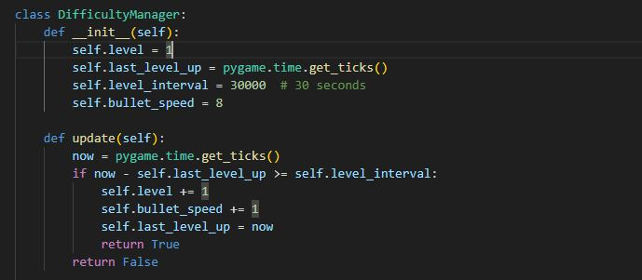

Screenshot 3B: Level Message Output
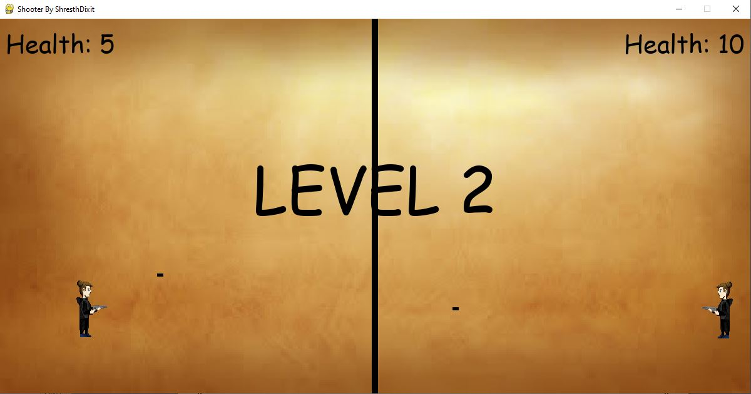
Explanation: The Difficulty Manager automatically increases the bullet speed every 30 seconds, making the game more challenging over time. A level-up message briefly appears to indicate progression.

Screenshot 4A: Game Over Menu Code
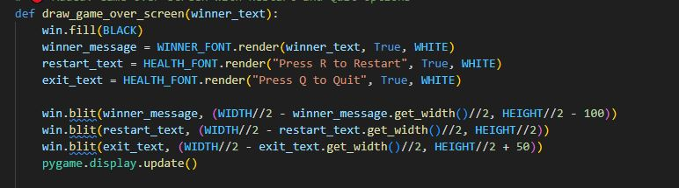

Screenshot 4B: Game Over Screen Output
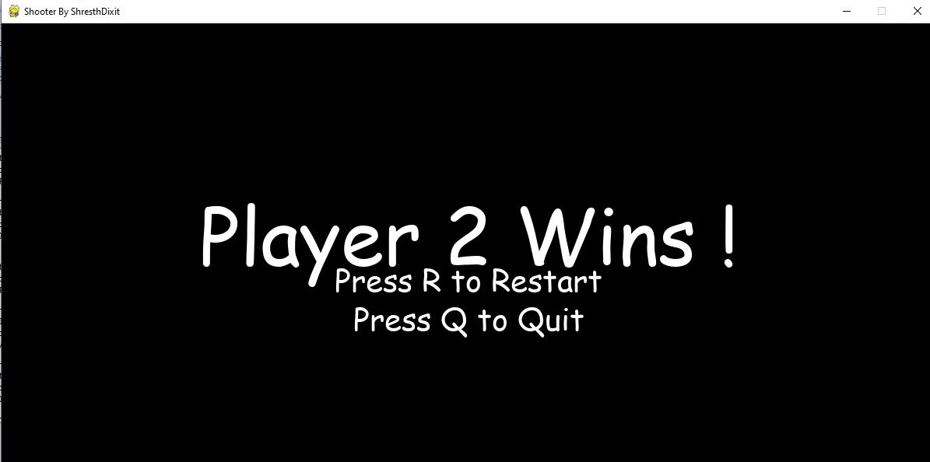
Explanation: When a player’s health reaches zero, the Game Over screen displays the winner. The screen also offers two options: Restart the game or Quit the application using keyboard keys ‘R’ and ‘Q’.

COMPLETE PROJECT CODE

- Main.py :
#main.py
import pygame
import os
from ai_player import AIPlayer
from difficulty import DifficultyManager # 🔴 Added for level system

pygame.font.init()
pygame.mixer.init()
Bullet_Hit = pygame.mixer.Sound("Play.mp3")
Bullet_Fire = pygame.mixer.Sound("Sound.mp3")
FPS = 60
WIDTH = 1200
HEIGHT = 600
Shooter_Width = 95
Shooter_Height = 95
Vel = 5

# 🔴 Removed static Bullet_Vel. Will use dynamic speed from DifficultyManager

Max_Bullets = 5
HEALTH_FONT = pygame.font.SysFont("comicsans",40)
WINNER_FONT = pygame.font.SysFont("comicsans",100)
MENU_FONT = pygame.font.SysFont("comicsans", 60)

S1_HIT = pygame.USEREVENT + 1
S2_HIT =pygame.USEREVENT + 2

BLACK = (0,0,0)
WHITE = (255,255,255)
Border = pygame.Rect((WIDTH/2)-5,0 ,10 ,HEIGHT)
win = pygame.display.set_mode((WIDTH,HEIGHT))
pygame.display.set_caption("Shooter By ShresthDixit")
SPACE_IMG = pygame.transform.scale(pygame.image.load("Brown2.jpg"),(WIDTH,HEIGHT))
Shooter_Image = pygame.image.load("Shooter.png")
Shooter_1 = pygame.transform.scale(Shooter_Image,(Shooter_Width,Shooter_Height))
Shooter_2 = pygame.transform.flip(pygame.transform.scale(Shooter_Image,(Shooter_Width,Shooter_Height)),True,False)

def draw_start_menu():
win.fill(BLACK)
title_text = MENU_FONT.render("SHOOTER GAME", True, WHITE)
start_text = HEALTH_FONT.render("Press 1 for 2 Player", True, WHITE)
ai_text = HEALTH_FONT.render("Press 2 for AI Mode", True, WHITE)

win.blit(title_text, (WIDTH//2 - title_text.get_width()//2, 150))
win.blit(start_text, (WIDTH//2 - start_text.get_width()//2, 300))
win.blit(ai_text, (WIDTH//2 - ai_text.get_width()//2, 360))
pygame.display.update()

waiting = True
mode = None
while waiting:
for event in pygame.event.get():
if event.type == pygame.QUIT:
pygame.quit()
exit()
if event.type == pygame.KEYDOWN:
if event.key == pygame.K_1:
mode = "2P"
waiting = False
elif event.key == pygame.K_2:
mode = "AI"
waiting = False
return mode

def drawWindows(S1,S2,S1_BULLET,S2_BULLET,S1_HEALTH,S2_HEALTH):
win.blit(SPACE_IMG,(0,0))
win.blit(Shooter_1,(S1.x,S1.y))
win.blit(Shooter_2,(S2.x,S2.y))
pygame.draw.rect(win,BLACK,Border)

S1_healthtext = HEALTH_FONT.render("Health: " + str(S2_HEALTH),1,BLACK)
S2_healthtext = HEALTH_FONT.render("Health: " + str(S1_HEALTH),1,BLACK)
win.blit(S1_healthtext,(WIDTH - S1_healthtext.get_width()-10,10))
win.blit(S2_healthtext,(10,10))

for bullet in S1_BULLET:
pygame.draw.rect(win,BLACK,bullet)
for bullet in S2_BULLET:
pygame.draw.rect(win,BLACK,bullet)

pygame.display.update()

def S1_movement(S1,keys_pressed):
if keys_pressed[pygame.K_w] and S1.y -Vel >0:
S1.y -= Vel
if keys_pressed[pygame.K_s] and S1.y + Vel <510:
S1.y += Vel
if keys_pressed[pygame.K_d] and S1.x + Vel < 530:
S1.x += Vel
if keys_pressed[pygame.K_a] and S1.x - Vel >0:
S1.x -= Vel

def S2_movement(S2,keys_pressed):
if keys_pressed[pygame.K_UP] and S2.y - Vel >0:
S2.y -= Vel
if keys_pressed[pygame.K_DOWN] and S2.y + Vel <510:
S2.y += Vel
if keys_pressed[pygame.K_RIGHT] and S2.x + Vel <1120:
S2.x += Vel
if keys_pressed[pygame.K_LEFT] and S2.x - Vel > 590:
S2.x -= Vel

# 🔴 Updated: handlebullets to take dynamic Bullet_Vel
def handlebullets(S1_BULLET,S2_BULLET,S1,S2,Bullet_Vel):
for bullet in S1_BULLET:
bullet.x += Bullet_Vel
if S2.colliderect(bullet):
pygame.event.post(pygame.event.Event(S2_HIT))
Bullet_Hit.play()
S1_BULLET.remove(bullet)
elif bullet.x > WIDTH:
S1_BULLET.remove(bullet)
for bullet in S2_BULLET:
bullet.x -= Bullet_Vel
if S1.colliderect(bullet):
pygame.event.post(pygame.event.Event(S1_HIT))
Bullet_Hit.play()
S2_BULLET.remove(bullet)
elif bullet.x<0:
S2_BULLET.remove(bullet)

# ... [Your Existing Imports and Variables Above Stay Same]

def winner(text): # 🔴 This can stay for 5 sec display if needed
draw_text = WINNER_FONT.render(text,1,BLACK)
win.blit(draw_text,(WIDTH/2 - draw_text.get_width()/2,HEIGHT/2-draw_text.get_height()/2))
pygame.display.update()
pygame.time.delay(5000)

# 🔴 Added: Game Over screen with Restart and Quit options
def draw_game_over_screen(winner_text):
win.fill(BLACK)
winner_message = WINNER_FONT.render(winner_text, True, WHITE)
restart_text = HEALTH_FONT.render("Press R to Restart", True, WHITE)
exit_text = HEALTH_FONT.render("Press Q to Quit", True, WHITE)

win.blit(winner_message, (WIDTH//2 - winner_message.get_width()//2, HEIGHT//2 - 100))
win.blit(restart_text, (WIDTH//2 - restart_text.get_width()//2, HEIGHT//2))
win.blit(exit_text, (WIDTH//2 - exit_text.get_width()//2, HEIGHT//2 + 50))
pygame.display.update()

waiting = True
while waiting:
for event in pygame.event.get():
if event.type == pygame.QUIT:
pygame.quit()
exit()
if event.type == pygame.KEYDOWN:
if event.key == pygame.K_r: # 🔴 Restart Game
waiting = False
run()
elif event.key == pygame.K_q: # 🔴 Quit Game
pygame.quit()
exit()

def run():
mode = draw_start_menu()

pygame.init()
S1 = pygame.Rect(100,300,Shooter_Width,Shooter_Height)
S2 = pygame.Rect(1100,300,Shooter_Width,Shooter_Height)

S1_BULLET = []
S2_BULLET = []
S1_HEALTH = 10
S2_HEALTH = 10

ai = None
if mode == "AI":
ai = AIPlayer(S2, S2_BULLET, S1)

difficulty = DifficultyManager()

clock = pygame.time.Clock()
Flag = True

while Flag:
clock.tick(FPS)

level_up = difficulty.update()
Bullet_Vel = difficulty.get_bullet_speed()

if level_up:
level_text = WINNER_FONT.render(f"LEVEL {difficulty.get_level()}", True, BLACK)
win.blit(level_text, (WIDTH//2 - level_text.get_width()//2, HEIGHT//2 - 100))
pygame.display.update()
pygame.time.delay(1000)

for event in pygame.event.get():
if event.type == pygame.QUIT:
Flag = False
pygame.quit()
if event.type == pygame.KEYDOWN:
if event.key == pygame.K_RCTRL and len(S2_BULLET)<Max_Bullets:
bullet = pygame.Rect(S2.x,S2.y+S2.height//2 -2, 10,5)
Bullet_Fire.play()
S2_BULLET.append(bullet)

if event.key == pygame.K_LCTRL and len(S1_BULLET)<Max_Bullets:
bullet = pygame.Rect(S1.x+30,S1.y+S1.height//2 -2, 10,5)
Bullet_Fire.play()
S1_BULLET.append(bullet)

if event.type == S1_HIT:
S1_HEALTH -= 1
if event.type == S2_HIT:
S2_HEALTH -= 1

winner_text = ""
if S1_HEALTH <= 0:
winner_text = "Player 2 Wins !"
if S2_HEALTH <= 0:
winner_text = "Player 1 Wins !"

if winner_text != "":
# winner(winner_text) # 🔴 Old 5 sec screen (optional)
draw_game_over_screen(winner_text) # 🔴 New Restart/Quit Screen
break

keys_pressed = pygame.key.get_pressed()
drawWindows(S1,S2,S1_BULLET,S2_BULLET,S1_HEALTH,S2_HEALTH)
S1_movement(S1,keys_pressed)
if mode == "2P":
S2_movement(S2,keys_pressed)
elif ai:
ai.move()
ai.fire()

handlebullets(S1_BULLET,S2_BULLET,S1,S2,Bullet_Vel)

if __name__ == "__main__":
run()

- Menu.py :
# menu.py
import pygame

class Menu:
def __init__(self, screen):
self.screen = screen
self.font = pygame.font.SysFont("comicsans", 50)
self.small_font = pygame.font.SysFont("comicsans", 30)

def draw_button(self, text, x, y, w, h):
mouse = pygame.mouse.get_pos()
click = pygame.mouse.get_pressed()
button_rect = pygame.Rect(x, y, w, h)
pygame.draw.rect(self.screen, (0, 128, 255), button_rect)

if button_rect.collidepoint(mouse):
pygame.draw.rect(self.screen, (0, 200, 255), button_rect)
if click[0] == 1:
return True

text_surface = self.font.render(text, True, (255, 255, 255))
self.screen.blit(text_surface, (x + (w - text_surface.get_width()) // 2, y + (h - text_surface.get_height()) // 2))
return False

def main_menu(self):
while True:
self.screen.fill((0, 0, 0))
title = self.font.render("SHOOTER GAME", True, (255, 255, 255))
self.screen.blit(title, (400 - title.get_width() // 2, 100))

if self.draw_button("Start", 300, 200, 200, 60):
return "start"
if self.draw_button("Instructions", 300, 280, 200, 60):
return "instructions"
if self.draw_button("Exit", 300, 360, 200, 60):
return "exit"

pygame.display.update()

def instructions_screen(self):
back_btn = pygame.Rect(20, 20, 100, 40)
while True:
self.screen.fill((50, 50, 50))
text = self.small_font.render("Use Arrow Keys or W/S to Move. Space to Shoot.", True, (255, 255, 255))
self.screen.blit(text, (100, 200))
pygame.draw.rect(self.screen, (0, 128, 255), back_btn)
back_text = self.small_font.render("Back", True, (255, 255, 255))
self.screen.blit(back_text, (30, 25))

mouse = pygame.mouse.get_pos()
click = pygame.mouse.get_pressed()

if back_btn.collidepoint(mouse) and click[0]:
return

pygame.display.update()

- ai_player.py:

#ai_player.py
import pygame
import random

class AIPlayer:
def __init__(self, shooter_rect, bullet_list, target_rect):
self.shooter = shooter_rect
self.bullets = bullet_list
self.target = target_rect
self.fire_delay = 1000 # milliseconds
self.last_fire_time = pygame.time.get_ticks()

def move(self):
if self.target.centery < self.shooter.centery and self.shooter.top > 0:
self.shooter.y -= 3
elif self.target.centery > self.shooter.centery and self.shooter.bottom < 600:
self.shooter.y += 3

def fire(self):
now = pygame.time.get_ticks()
if now - self.last_fire_time > self.fire_delay:
bullet = pygame.Rect(
self.shooter.x, self.shooter.y + self.shooter.height // 2 - 2, 10, 5
)
self.bullets.append(bullet)
self.last_fire_time = now

- Powerups.py:

# powerups.py

import pygame
import random

class PowerUpManager:
def __init__(self):
self.powerups = []
self.spawn_timer = pygame.time.get_ticks()

def spawn_powerup(self, player_rect, mode="2P"):
now = pygame.time.get_ticks()
if now - self.spawn_timer >= 20000: # 20 seconds
type = random.choice(["health", "speed"])
if mode == "AI":
x = random.randint(50, 200) # Left side
else:
x = random.randint(400, 750) # Right side
y = random.randint(50, 550)
rect = pygame.Rect(x, y, 20, 20)
self.powerups.append((rect, type))
self.spawn_timer = now

def draw(self, screen):
for rect, type in self.powerups:
color = (0, 255, 0) if type == "health" else (0, 0, 255)
pygame.draw.rect(screen, color, rect)

def check_collision(self, player_rect, player_stats):
for powerup in self.powerups[:]:
rect, type = powerup
if player_rect.colliderect(rect):
if type == "health":
player_stats["health"] += 1
elif type == "speed":
player_stats["speed"] += 2
self.powerups.remove(powerup)

- dificulty.py

#difficulty.py
import pygame

class DifficultyManager:
def __init__(self):
self.level = 1
self.last_level_up = pygame.time.get_ticks()
self.level_interval = 30000 # 30 seconds
self.bullet_speed = 8

def update(self):
now = pygame.time.get_ticks()
if now - self.last_level_up >= self.level_interval:
self.level += 1
self.bullet_speed += 1
self.last_level_up = now
return True
return False

def get_level(self):
return self.level

def get_bullet_speed(self):
return self.bullet_speed

- gameover.py:

# gameover.py
import pygame

class GameOverScreen:
def __init__(self, screen):
self.screen = screen
self.font = pygame.font.SysFont("comicsans", 60)

def show(self, final_score):
while True:
self.screen.fill((0, 0, 0))
title = self.font.render("GAME OVER", True, (255, 0, 0))
score_text = self.font.render(f"Score: {final_score}", True, (255, 255, 255))
restart_text = self.font.render("Restart", True, (0, 255, 0))
quit_text = self.font.render("Quit", True, (255, 0, 0))

self.screen.blit(title, (400 - title.get_width() // 2, 100))
self.screen.blit(score_text, (400 - score_text.get_width() // 2, 180))

restart_rect = pygame.Rect(300, 280, 200, 60)
quit_rect = pygame.Rect(300, 360, 200, 60)

pygame.draw.rect(self.screen, (0, 255, 0), restart_rect)
pygame.draw.rect(self.screen, (255, 0, 0), quit_rect)

self.screen.blit(restart_text, (restart_rect.x + 40, restart_rect.y + 10))
self.screen.blit(quit_text, (quit_rect.x + 60, quit_rect.y + 10))

mouse = pygame.mouse.get_pos()
click = pygame.mouse.get_pressed()

if restart_rect.collidepoint(mouse) and click[0]:
return "restart"
if quit_rect.collidepoint(mouse) and click[0]:
return "quit"

pygame.display.update()

Overall File view in project

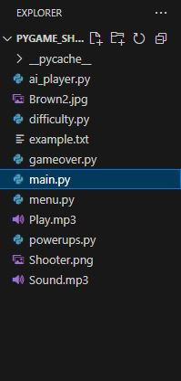

FUTURE SCOPE OF PROJECT

The current version of the 2D Shooter Game includes core features like multiplayer support, AI player, level-based difficulty, and game-over menu. However, there are many ways the game can be improved and extended in future versions. Below are some key future enhancements:

- Power-Ups (Speed and Health Boosters):
Special power-ups can be added which appear after regular intervals. These will either restore the player's health or temporarily increase their movement speed, adding more strategy to the gameplay.

- High Score Saving System:
A scoring system can be implemented that saves and displays the highest score achieved by players. This feature motivates players to keep improving and adds a competitive element

- AI Difficulty Levels (Easy, Medium, Hard):
Currently, the AI follows a fixed strategy. More advanced AI modes can be developed, with each level increasing the AI's shooting speed, accuracy, and movement strategy.

- Multiplayer via LAN or WiFi:
Enabling two players to connect and play over a local network or WiFi will make the game more interactive and fun, especially for users who are not on the same system.

- Mobile Game Version (using Kivy):
The entire game can be ported to Android devices using the Kivy framework. This will make the game available to mobile users and increase its usability and reach.

CONCLUSION

The Shooter Game Project has been successfully developed and tested using Python and Pygame. It implements all core game mechanics such as movement, shooting, AI, difficulty, and game menu handling.

The modular design of the project allows for easy enhancements and future upgrades. It is a strong example of how Python can be used for interactive game development and also serves as a learning tool for collision, rendering, and basic AI in 2D games.

This project has improved understanding of real-time systems, game design flow, and logic structuring — a solid base for more advanced game development projects.

SHOOTER GAME SYNOPSIS

Project Title:
2D Shooter Game in Pygame with AI, Difficulty Levels, and Game Menu

Developed By:
Shresth Dixit

Platform Used:
Python with Pygame Library

1. Introduction :

This project is a two-player 2D shooter game developed using the Pygame library. It includes features such as AI-based player control, increasing difficulty with time, power-ups, and a graphical game-over menu. The game can be played in two modes: - 2P Mode: Player vs Player - AI Mode: Player vs Computer

2. Project Files Overview

- main.py: Main game loop, game logic, UI, player movement and collision.
- ai_player.py: Controls for AI-based enemy player.
- difficulty.py: Manages game difficulty (level and bullet speed).
- powerups.py: Handles spawning and collision of health/speed power-ups.
- gameover.py: Displays a game-over screen with Restart and Quit buttons.

3. How the Game Works

a) Start Menu
When the game is run, the player is greeted with a start screen with two options: - Press 1 to play with another player. - Press 2 to play against an AI.

b) Player Controls

- Player 1:
  - Move: W, A, S, D
  - Fire: Left Ctrl
- Player 2:
  - Move: Arrow Keys
  - Fire: Right Ctrl

c) Game Logic (main.py) :

- Players have health = 10 each.

- A black bullet represents shooting.

- Collision with bullet reduces health.

- The screen is split with a border to separate zones.

- Bullets are removed when they go out of screen or hit the opponent.

- The game ends when any player’s health reaches 0.

d) Difficulty Manager (difficulty.py)

- Every 30 seconds, the level increases.

- Each level increases bullet speed by 1 unit.

- A message shows “LEVEL X” on screen briefly.

e) AI Player (ai_player.py)

- The AI targets the Y-position of the player.

- Fires bullets every 1 second.

- Moves up/down to match player’s vertical position.

f) Game Over Screen (gameover.py)

- Displays the winner.

- Option to Restart or Quit

- If Restart is pressed, the game restarts from the beginning.

g) Power-Ups (powerups.py) (In future scope)

- Health power-ups restore health.

- Speed power-ups temporarily increase speed.

- Spawns every 20 seconds.

4. Game Assets

- Shooter.png: Image for player characters.

- Brown2.jpg: Background image.

- Play.mp3: Sound for bullet hit.

- Sound.mp3: Sound for bullet fire.

5. Tools Used

- Python 3

- Pygame: Game development library

- VS Code: Code Editor

6. Future Enhancements

- Add Power-Ups feature (health/speed)

- Save high scores

- Add more AI difficulty levels

- Add enemy waves in single-player mode

7. Conclusion

This shooter game project demonstrates core concepts of game development such as rendering graphics, handling collisions, adding AI behavior, and creating user-friendly interfaces. It serves as a strong foundation for making more advanced games using Python and Pygame.

End of SYNOPSIS

